**DAILY ONLINE ACTIVITIES SUMMARY**

|  |  |  |  |  |  |  |  |
| --- | --- | --- | --- | --- | --- | --- | --- |
| **Date:** | 12-06-2020 | | | | **Name:** | Gudugunti Anirudh | |
| **Sem & Sec** | IV - A | | | | **USN:** | 4AL18CS023 | |
| **Online Test Summary** | | | | | | | |
| **Subject** | | N/A | | | | | |
| **Max. Marks** | | N/A | | **Score** | | N/A | |
| **Certification Course Summary** | | | | | | | |
| **Course** | Data structures and algorithms in c++ | | | | | | |
| **Certificate Provider** | | | Udemy | **Duration** | | | 2.5**hr** |
| **Coding Challenges** | | | | | | | |
| **Problem Statement:** 1: Program to find the longest repeating sequence in a string  2: Program to swap two numbers using friend as a bridge concept. | | | | | | | |
| **Status:** Completed | | | | | | | |
| **Uploaded the report in Github** | | | | yes | | | |
| **If yes Repository name** | | | | https://github.com/alvas-education-foundation/anirudh_gudugunti/tree/master/daily_progress | | | |
| **Uploaded the report in slack** | | | | yes | | | |

**Online Test Details: N/A**

**Snapshot of certification course:**

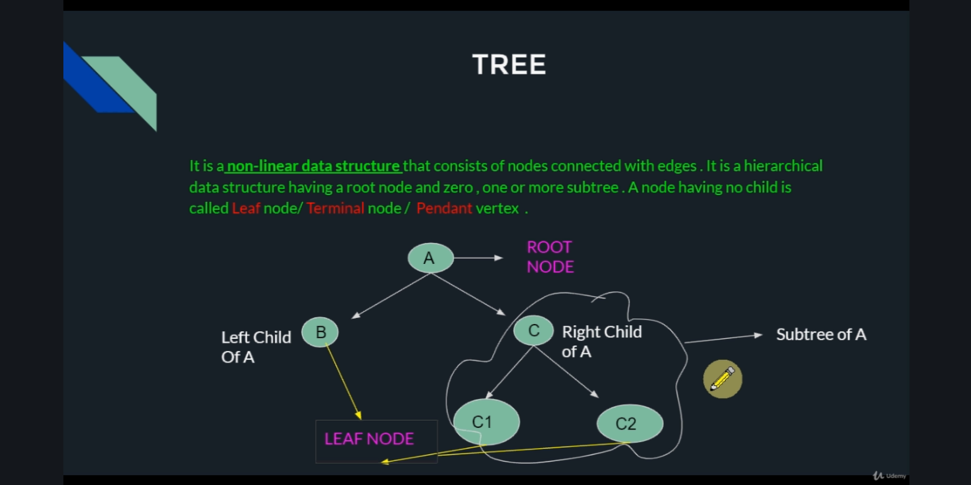

1. Introduction to Trees and Graphs in data structures.

2. Some worked out examples on trees and graphs.

3. Detailed explanation with diagrams.

**Online coding:**

Problem 1: (using java) Program to find the longest repeating sequence in a string.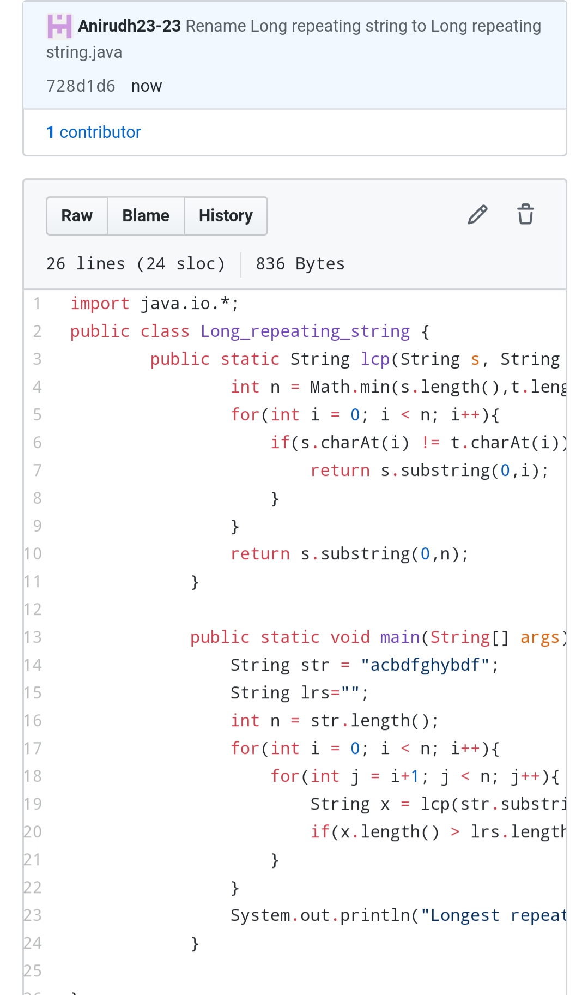

Problem 2: (using C++) Program to swap two numbers using friend as a bridge concept.

